● Explain and perform Sqoop Incremental Import operation to load data from Mysql To HDFS using Sqoop

● Explain the procedures performed, Share the screenshots of commands and results for the same.

Creating a table named employee and inserting the values:

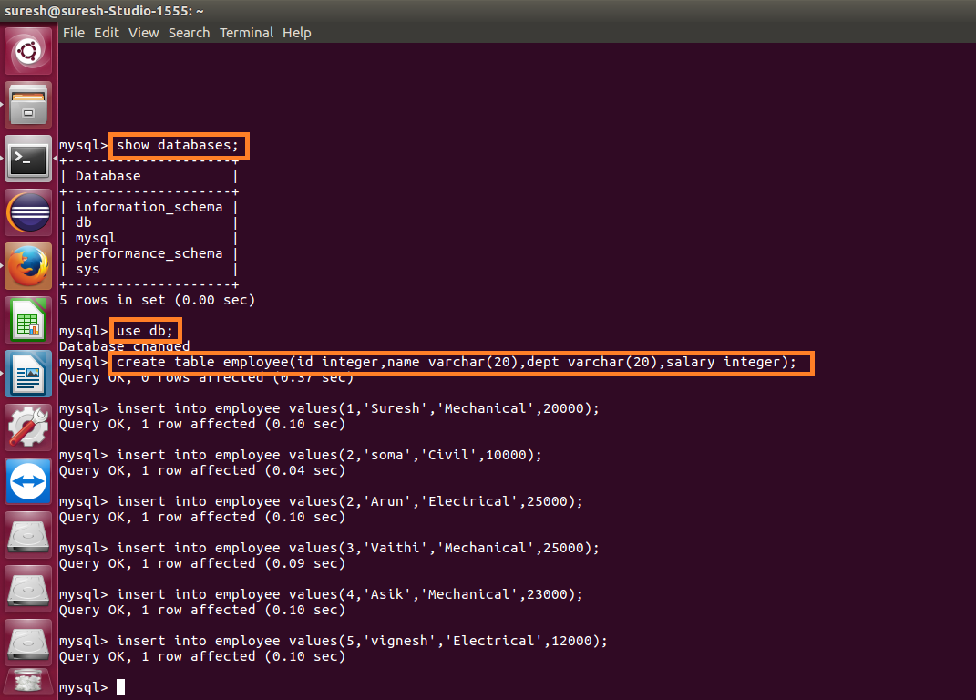

Displaying the contents of the table:

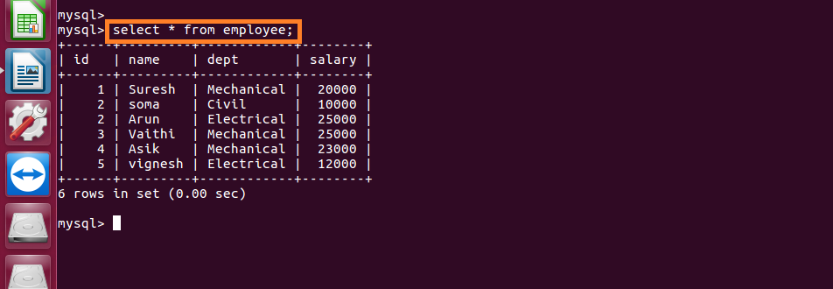

Importing the data from mysql to hdfs:

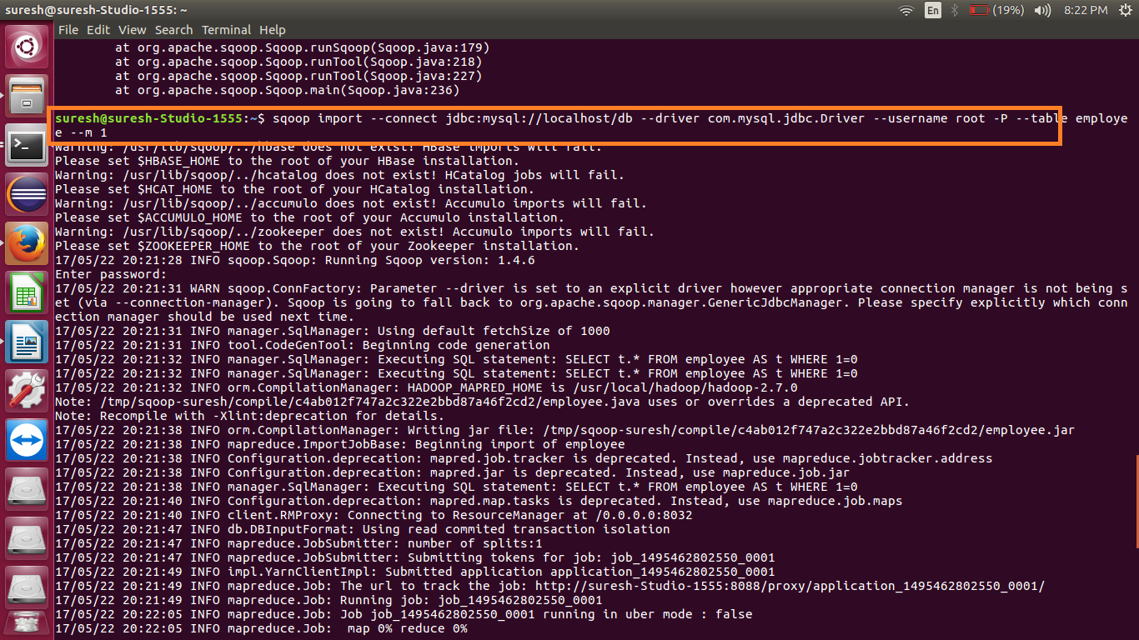

Data successfully imported:

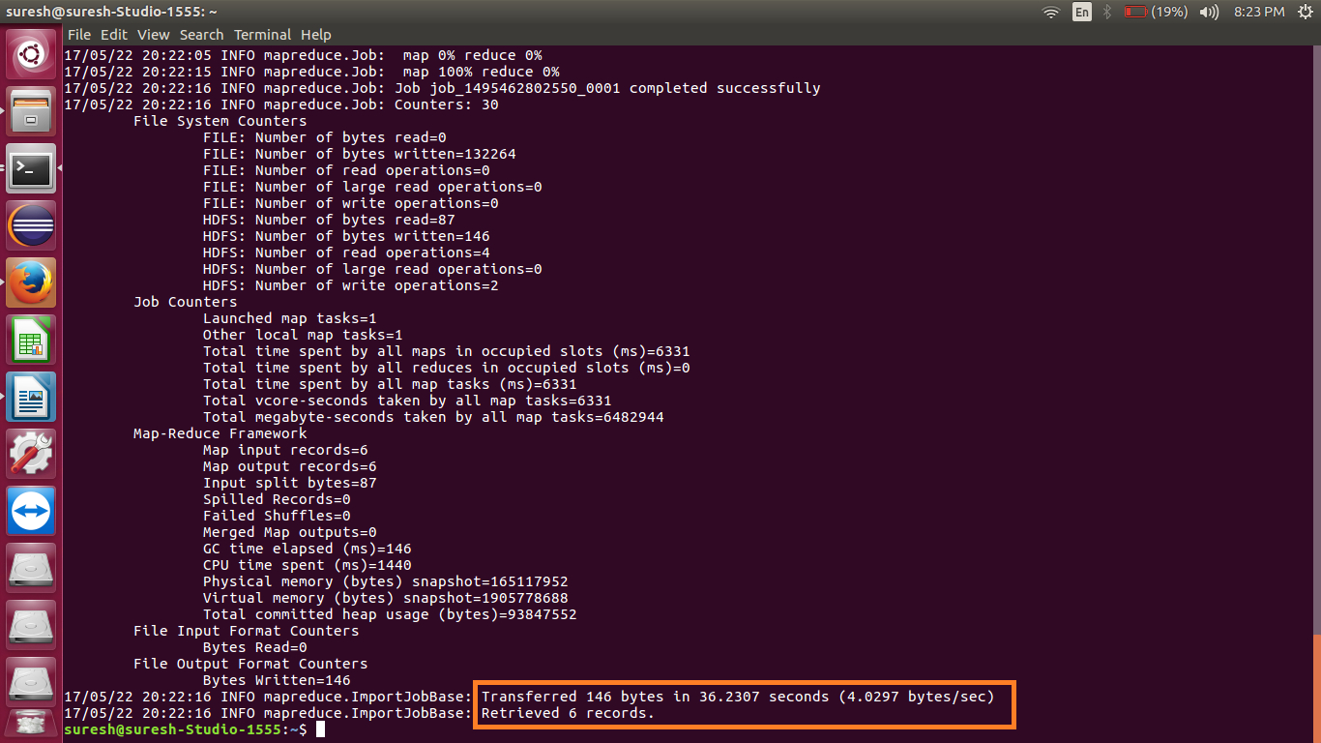

Displaying the imported file in hdfs:

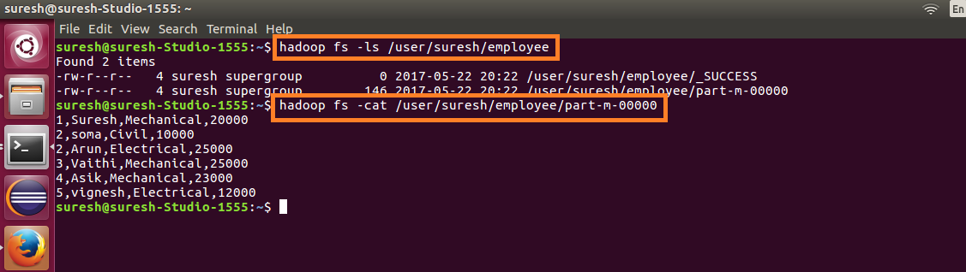

Inserting a few more records into the employee table:

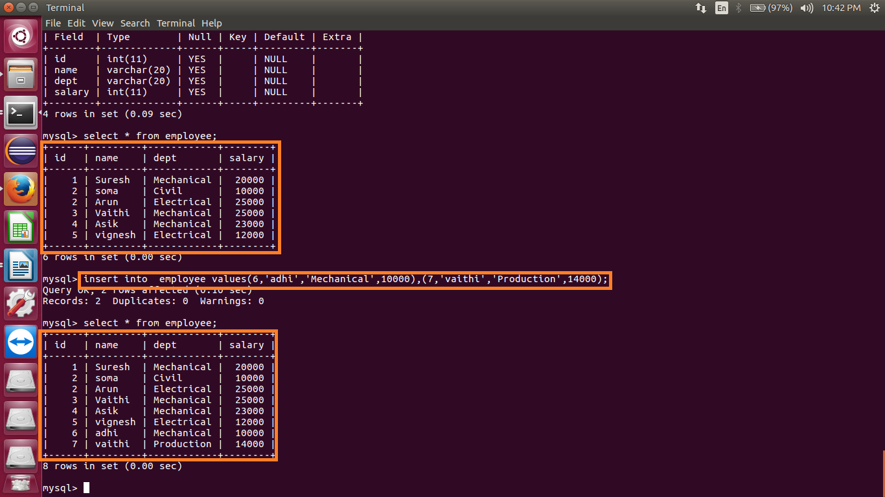

Doing incremental append:

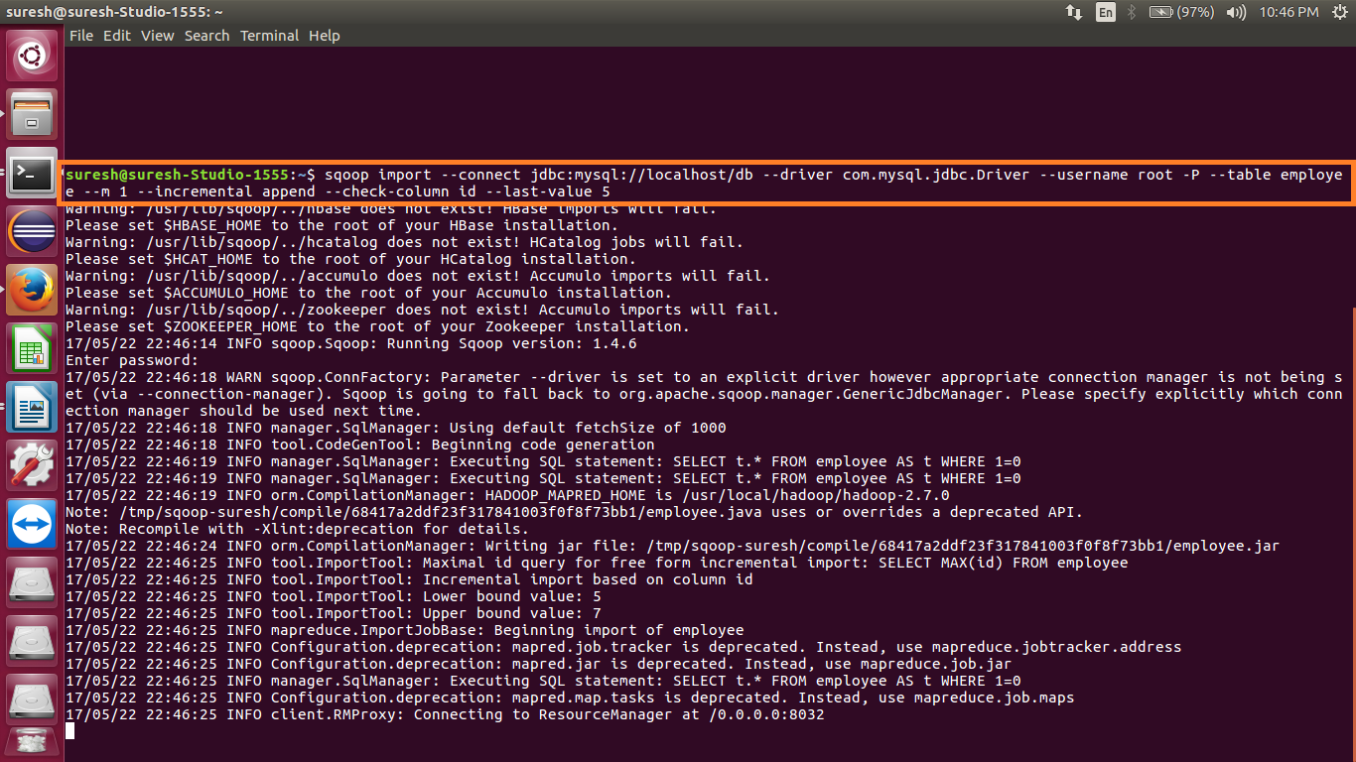

Data successfully imported:

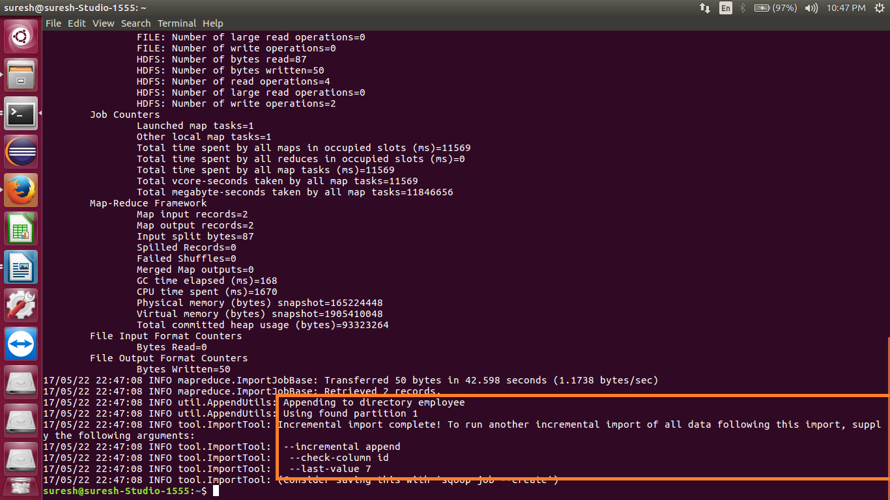

Imported data is displayed in hdfs:

